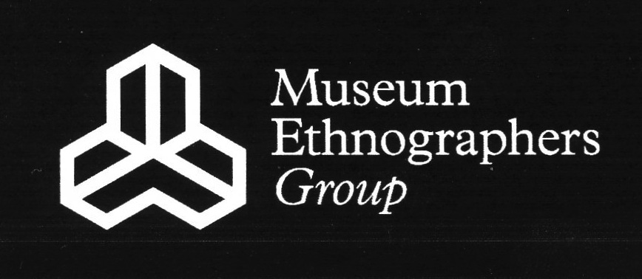

**2015 Conference Schedule**

**Nature and Culture in Museums**

DAY 1 (conference in G1 and breaks in MFG)

* **9:30-10:00 Morning tea and conference registration.**
* 10:00-10:30 Welcome to Powell-Cotton Musuem and Introduction to Powell-Cotton Museum collections.
* **10:30-12:00 Morning session** 
  + Paolo Viscardi & Robert Storrie (Horniman Museum) - *Nature and Culture in Museums: The Role of Collaboration*.
  + Cinthya Lana (Kings College London) - *The construction of the Notions of Nature and Culture within Colonial Exhibitions 1870-1958*.
  + Jude Philp (Macleay Museum, Sydney University Museums) – *Natural Objects*.
* **12:00-13:00 Lunch**
* **13:00-15:00 First afternoon session**
  + Ali Clark (Cambridge Museum of Archaeology and Anthropology) - *All the World For Sale: Nature and Culture at Gerrard and Sons*.
  + Jenny Walklate - *Swifts in the Tower of the House of God: the reciprocal framing of nature and culture in the Oxford University Museum of Natural History.*
  + Elee S. Kirk (University of Leicester) - *“There are roughly a billion storybooks that feature penguins”: The ways in which young children connect natural history museums to their worlds.*
  + Caroline Cornish (Royal Holloway) & Mark Nesbitt (Royal Botanic Gardens, Kew) - *Seeds of Industry and Empire: Revitalising Economic Botany Collections.*
* **15:00-15:30 Afternoon tea.**
* **15:30-16:30 Second afternoon session**
  + Andy Mills (Norfolk Museums & Archaeology Service) - *Predatory Assemblages: Prey Remains as Components of Symbolic Pastiche in Ethnographic Objects.*
  + Antonia Lovelace, Rebecca Machin and Clare Brown (Leeds Museums and Galleries) - *Comparing the Meerkats and Falling For ‘Digital’ Monkey – How Trending Animal Totems playfully impact on our relationship with real animals and Museum displays.*
* **16:30-17:30 Roundtable discussion (TBC).**
* **17:30-19:00 drinks reception/look round the museum and gardens**
* **19:00 – conference dinner**

DAY 2 (conference and breaks in MFG)

* **9:30-10:30 Morning session**
  + Anita Herle, Tony Eccles and Alison K. Brown - *Storied Landscapes: Enlivening Blackfoot collections in UK Museums*.
  + Alana Jelinek (Cambridge Museum of Archaeology and Anthropology) - *Thinking about Culture through Nature.*
* **10:30-11:00 Morning tea**
* **11:00-12:30 Work in Progress session**
* **12:30-13:30 Lunch**
* **13:30-14:30 AGM**
* **14:30-15:30 Round up discussion and FINISH**
* **15:30 final tea break and LEAVE or…**
* **15:30-16:30 Additional time for a tour for anyone who wants**